14.67: a) The weight of the crown of its volume V is 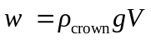, and when suspended the apparent weight is the difference between the weight and the buoyant force,

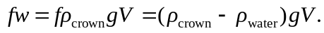

Dividing by the common factors leads to

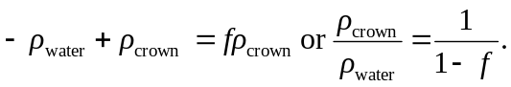

As 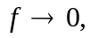the apparent weight approaches zero, which means the crown tends to float; from the above result, the specific gravity of the crown tends to 1. As 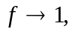 the apparent weight is the same as the weight, which means that the buoyant force is negligble compared to the weight, and the specific gravity of the crown is very large, as reflected in the above expression. b) Solving the above equations for f in terms of the specific gravity, 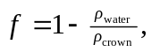and so the weight of the crown would be 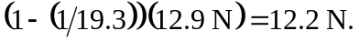 c) Approximating the average density by that of lead for a “thin” gold plate, the apparent weight would be 